Jenkins Ansible Integration

Prerequisites:

Two machines.

1. Machine1:
   1. Jenkins,java11, and ansible installed

*Note: In machine 2 we do not require to install anything.*

Step1:

Goto plugin—> available plugins—> search: ansible, Install without restart.

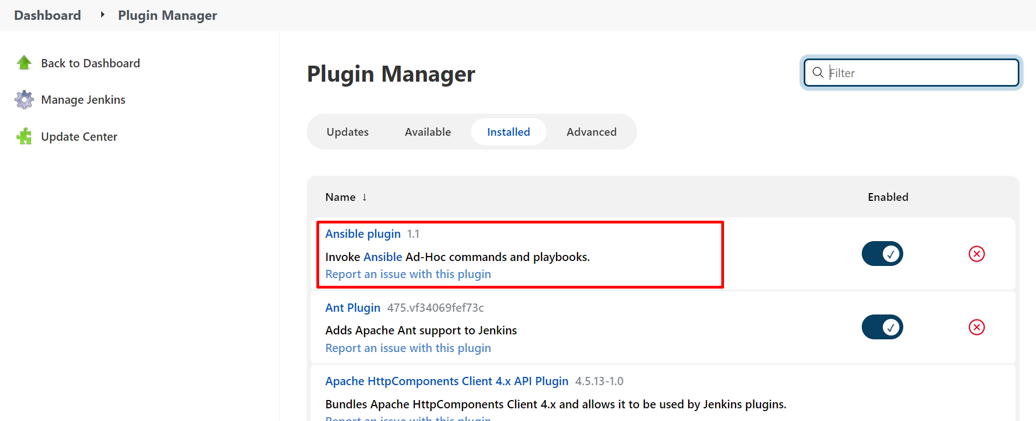

Step2:

Configure the [**Global Tool Configuration**](http://54.203.221.125:8080/configureTools/)

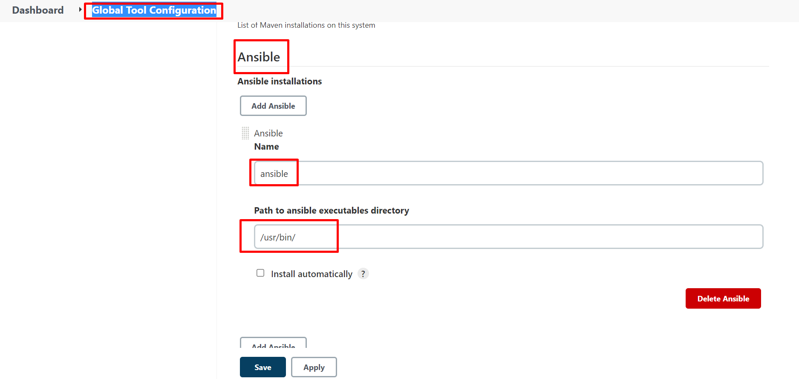

Note: the path we can get from the master machine after installation ansible, we can write

*Which ansible*

Step3:

Create a pipeline job and write the script as follows

***pipeline {***

***agent any***

***stages {***

***stage('Hello') {***

***steps {***

***echo 'Hello World'***

***}***

***}***

***stage('Git clone') {***

***steps {***

***git 'https://github.com/devopsintellipaat/jenkins-ansible.git'***

***}***

***}***

***stage('ansible task') {***

***steps {***

***ansiblePlaybook become: true, credentialsId: 'dev', disableHostKeyChecking: true, installation: 'ansible', inventory: 'dev.inv', playbook: 'ansible-playbook.yml'***

***}***

***}***

***}***

***}***

*Note: the job should run on the master machine only.*

Step4: In the Github repo.

We need 2 files playbook and an inventory file

ansible-playbook.yml

---

- name: hosts defined

hosts: webserver

tasks:

- name: apache2

apt: name=apache2 state=latest update_cache=yes

dev.inv

[webserver]

<private ip of worker/tagret machine>

Step5: Replace and configure creds and repo.

***'***[***https://github.com/devopsintellipaat/jenkins-ansible.git***](https://github.com/devopsintellipaat/jenkins-ansible.git)***'***

***Replace with your own repo with playbook and inventory file.***

***ansiblePlaybook become: true, credentialsId: 'dev', disableHostKeyChecking: true, installation: 'ansible', inventory: 'dev.inv', playbook: 'ansible-playbook.yml'***

Replace the above line of code as follows:

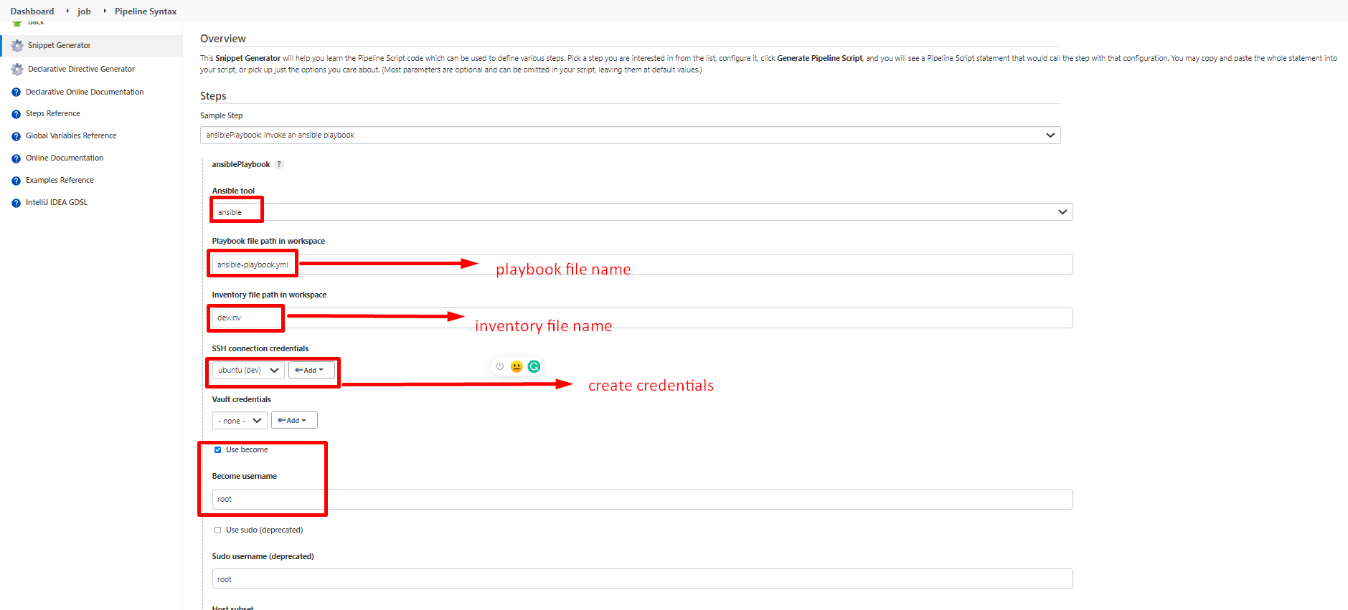

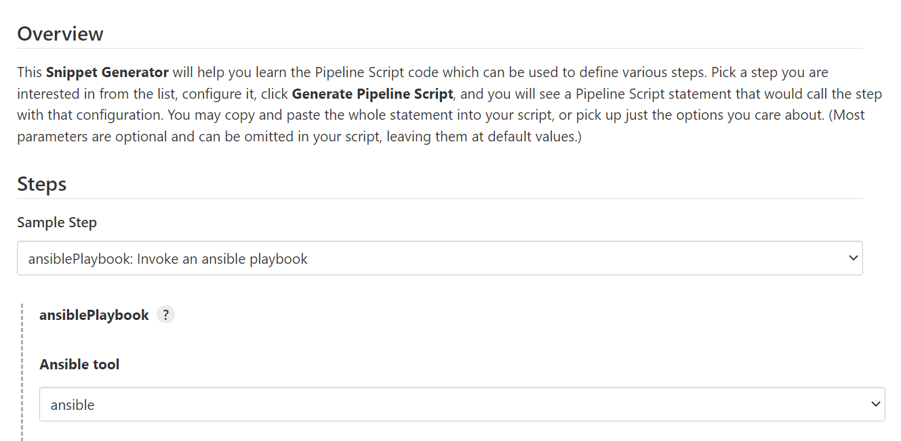

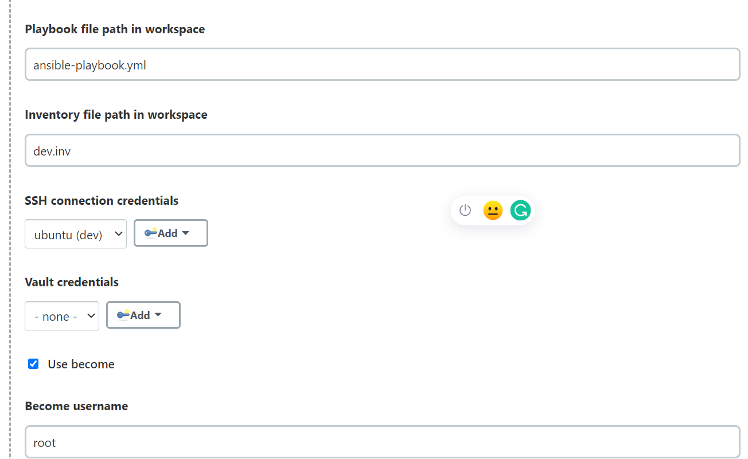

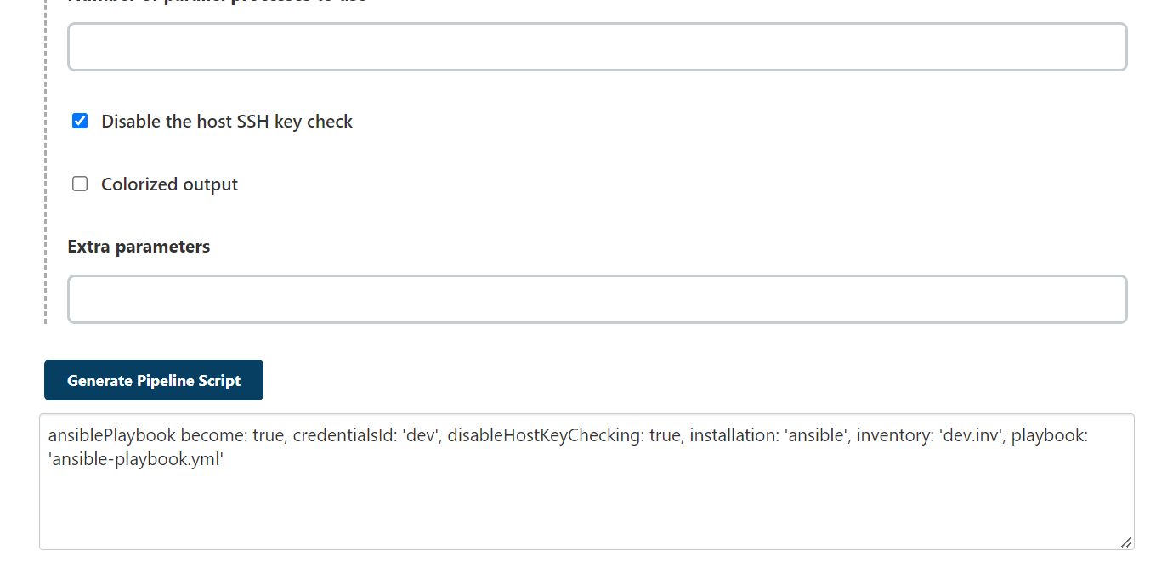

For the credentials:

Ssh username and private key

Id: dev

Description: dev

Username: ubuntu

Private key enter directly:

Paste the private key(pem file)

Save.

Generate the code.